A000-Asia-China-Hongshan-Jade-Double Boar-3200 BCE



 

2.9"(L) x 1.4"(H)x 0.4"(D)

36 g

**Case no.: 5**

**Accession Number:**

**Formal Label:** Hongshan-Jade-Double Boar

**Display Description:**

**LC Classification:**

**Date or Time Horizon:**

**Geographical Area:**

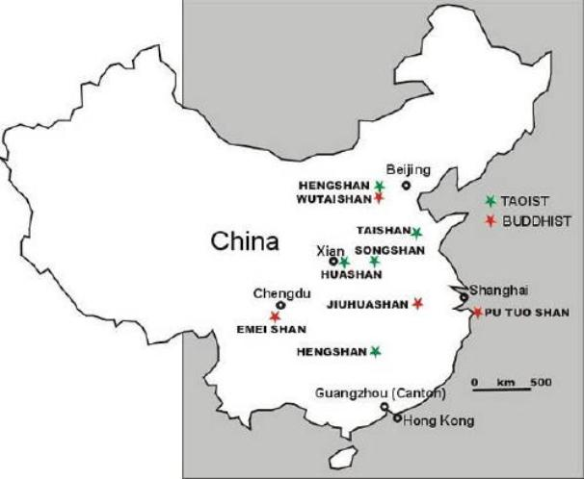

**Map:**

**GPS coordinates:**

**Cultural Affiliation:**

**Media:**

**Dimensions:**

**Weight:**

**Condition:**

**Provenance:**

**Discussion:**

**References:**